Real World Dataset Analysis Project
Data Analyst Internship Task 3 of 6
Programme dates 10 October 2026 to 5 December 2026

Problem and source
This project uses the real diabetes cohort distributed with scikit-learn. There are 442 records, ten baseline predictors and one quantitative progression target measured one year after baseline. Raw predictor values are loaded with scaled=False. The scope is educational data analysis and regression, rather than diagnosis or treatment. The same traceable source supports the practical internship tasks, while each report addresses a different objective. The analytical questions concern target distribution, feature associations and unusual observations. Source documentation is cited at the end of this report.

Structure and quality
Inspect numeric types, ranges, missing cells, duplicates and record count before analysis. The audit found 442 rows, 11 columns, zero missing cells and zero duplicate rows. The full data therefore need no imputation or duplicate removal. Keep the raw export for traceability and a separate clean export for downstream work.

Preprocessing and outliers
IQR fences identify values below Q1 minus 1.5 times IQR or above Q3 plus 1.5 times IQR. BMI has three flagged observations; other continuous predictors have additional flags. Flags prompt review rather than automatic deletion. Unusual values may be valid in this cohort. No source rows were deleted. Treat the sex code as categorical; its numeric correlation depends on encoding.

Exploratory findings
The target mean is 152.13 and median is 140.50. BMI has Pearson correlation 0.586 with the target. This positive sample association does not imply that modifying BMI causes a particular outcome. outputs/target_correlations.csv contains the complete association ranking.

Visual interpretation
The target histogram describes spread and concentration. The BMI scatter plot shows a positive tendency with substantial variation. Horizontal bars compare feature correlations, while a box plot highlights distribution differences. BMI and blood pressure use different units, so their box plot scales should not be interpreted as comparative importance. No dates exist to support a time-series chart.

Recommendations and limitations
Retain valid unusual observations, document every transformation and investigate predictor relationships before modelling. The research cohort is small and may not represent a wider population. The outcome is a score rather than a currency, diagnosis or probability. Recommendations concern analysis quality and validation; financial or intervention benefits are not estimated.

References and reproducibility
https://scikit-learn.org/stable/modules/generated/sklearn.datasets.load_diabetes.html
Dataset notes and original study attribution are in data/SOURCE.md. The README explains setup, task mapping and submission. Report values are computed outputs, not proof of clinical validity.

Visual evidence
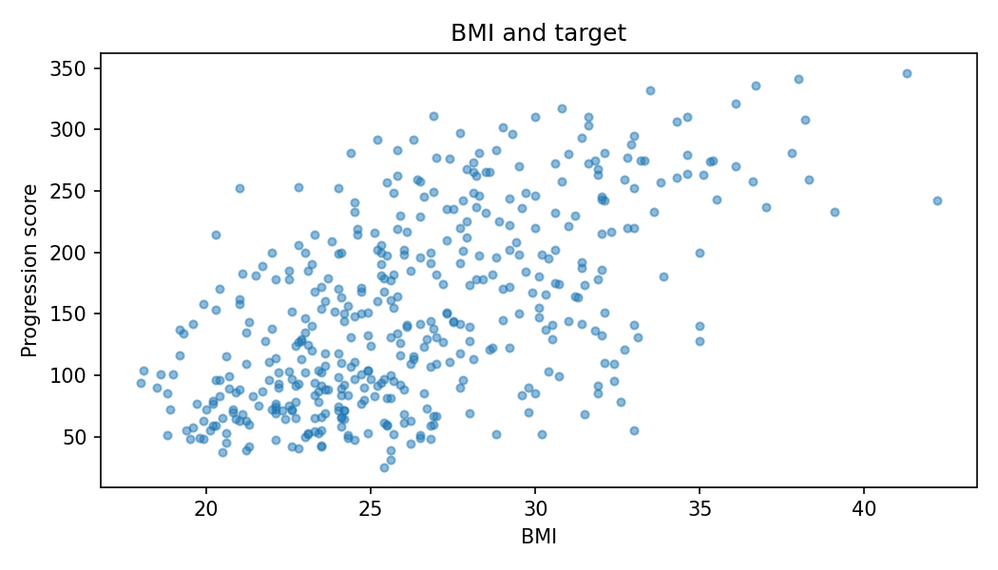
BMI and target show association with substantial variation.

Computed evidence
Rows 442 Missing cells 0 Duplicate rows 0
Target mean 152.13 Target median 140.50
Complete tables and chart generation are available in outputs and src.

